Software Design Document
VentureBridge
Submitted by:
Muneeba Shaheen
Submitted to:
Prof.Wahaj Ali

1. Summary
VentureBridge is a startup-investor marketplace platform connecting entrepreneurs with investors through profiles, pitch listings, search, dashboards, and real-time messaging. This SDD defines the architecture, components, data model, UI design, security, deployment, and future scalability of the system.

2. Table of Contents
3. Introduction
4. System Scope and Objectives
5. Application Architecture
6. Database Model Schema
7. User Interface Design
8. Security Considerations
9. Deployment Architecture
10. Non-Functional Requirements
11. Future Enhancements
12. Conclusion
13. Appendices

3. Introduction
VentureBridge is designed as a modern web application where founders publish investment opportunities and investors discover, evaluate, and communicate with startups.

4. System Scope and Objectives
Scope includes authentication, 2FA, profiles, pitch submission, attachments, search/filtering, chat, and dashboards. Objective is to simplify startup-investor discovery and communication.

5. Application Architecture
VentureBridge follows a layered client-server architecture.
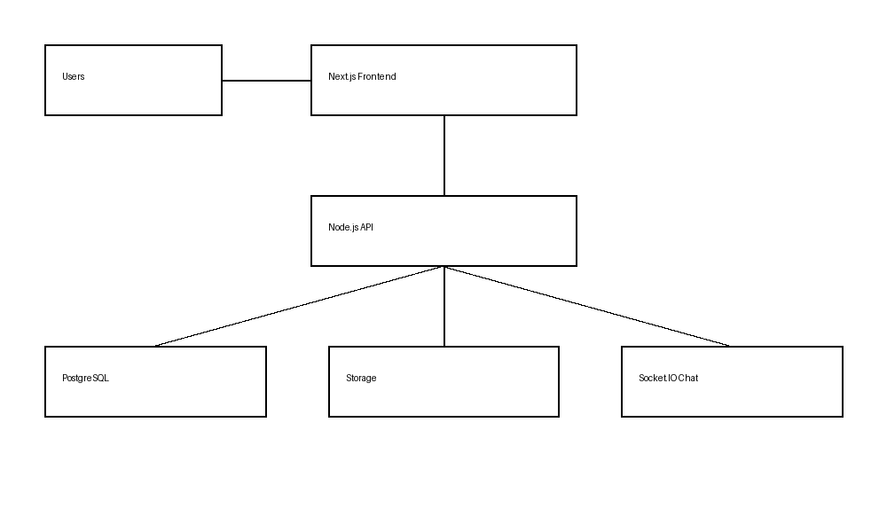
Figure 1: System Architecture

5.1 Backend Architecture
API Layer handles requests, Service Layer handles business logic, Data Layer persists entities, Realtime Layer manages chat.

6. Database Model Schema
Core entities include Users, Profiles, Pitches, Messages, Conversations, and Attachments.
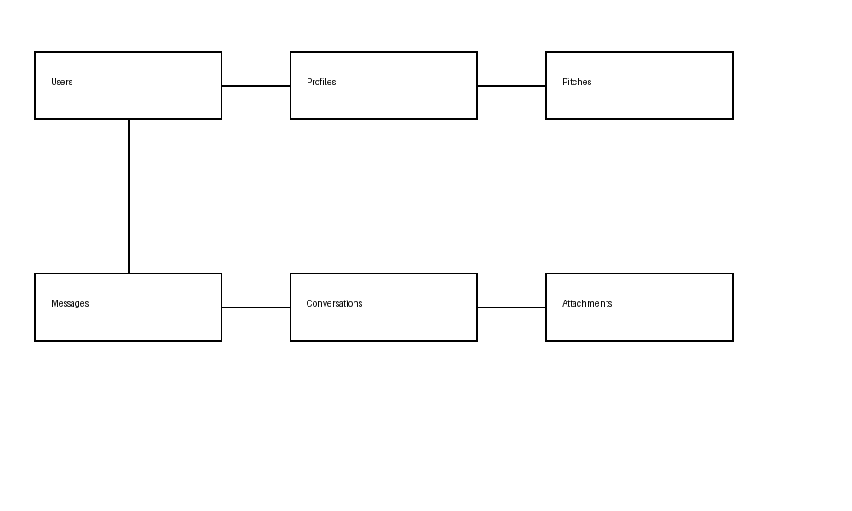
Figure 2: Core Entity Relationship Overview

7. User Interface Design
Screens: Home, Login/Register, Profile Setup, Pitch Listing, Pitch Detail, Chat, Entrepreneur Dashboard, Investor Dashboard.

8. Security Considerations
JWT authentication, bcrypt passwords, OTP via Resend API, RBAC permissions, secure file validation, HTTPS transport.

9. Deployment Architecture
Frontend on Vercel, Backend on Render/AWS, PostgreSQL managed DB, object storage for files, CDN for assets.

10. Non-Functional Requirements
Performance, scalability, reliability, usability, maintainability.

11. Future Enhancements
Investment workflows, analytics, AI recommendations, admin panel, mobile app.

12. Conclusion
VentureBridge provides a scalable foundation for startup-investor networking with modern architecture and extensible modules.

13. Appendices
Appendix A: API Endpoints
Appendix B: Error Handling
Appendix C: Glossary

